**React Portfolio**

Design Inspiration:

* 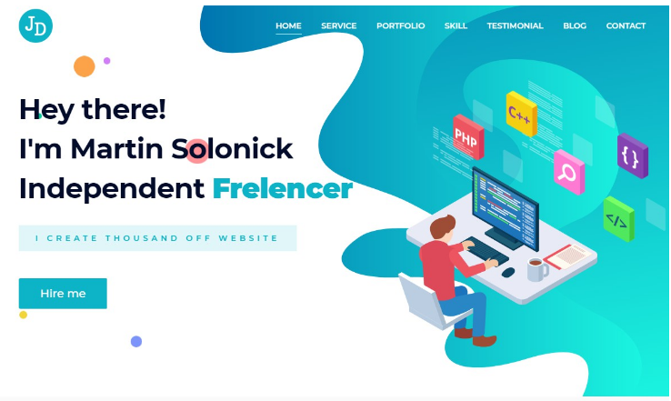

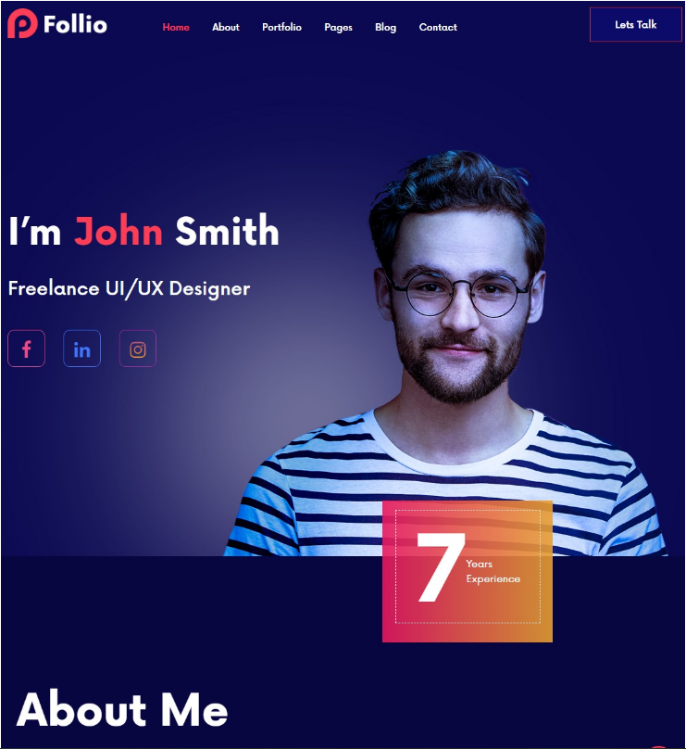

**Couleur**539CF

|  |  |
| --- | --- |
| **HEX** | **Couleur** |
| **#00539CFF** |  |
| **#EEA47FFF** |  |
| **#F4F6FC** |  |

**PROJETS**

|  |  |  |
| --- | --- | --- |
| **Projet** | **Image 1** | **Image 2** |
| **Ecommerce App** |  |  |
| **Blackjack** |  |  |
| **Quiz Website** |  |